EXPERIMENT 12: INTRUSION DETECTION

AIM

To understand intrusion detection systems (IDS) and learn basic evasion techniques during cyber attacks.

PROCEDURE

- Study IDS concepts and types (NIDS and HIDS).
- Perform reconnaissance using tools like Nmap and observe IDS alerts.
- Apply evasion techniques (user-agent change, stealth scans).
- Analyze detection differences and perform post-exploitation activities.

QUESTIONS

TASK 1 - Intrusion Detection Basics

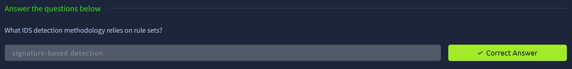

TASK 2 - Network-based IDS (NIDS)

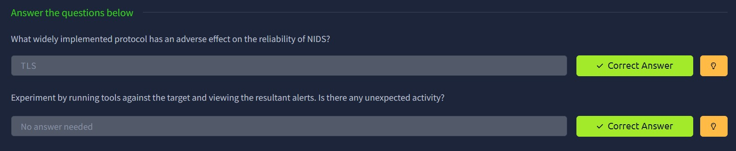

TASK 3 - Reconnaissance and Evasion Basics

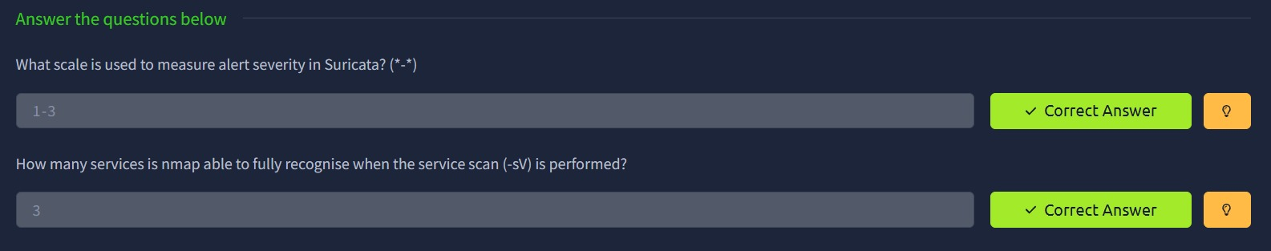

TASK 4 - Further Reconnaissance Evasion

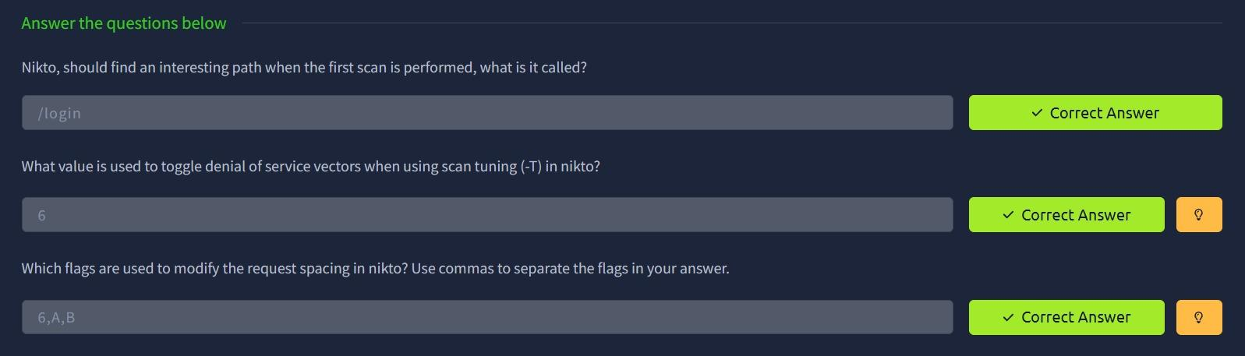

TASK 5 - Open Source Intelligence

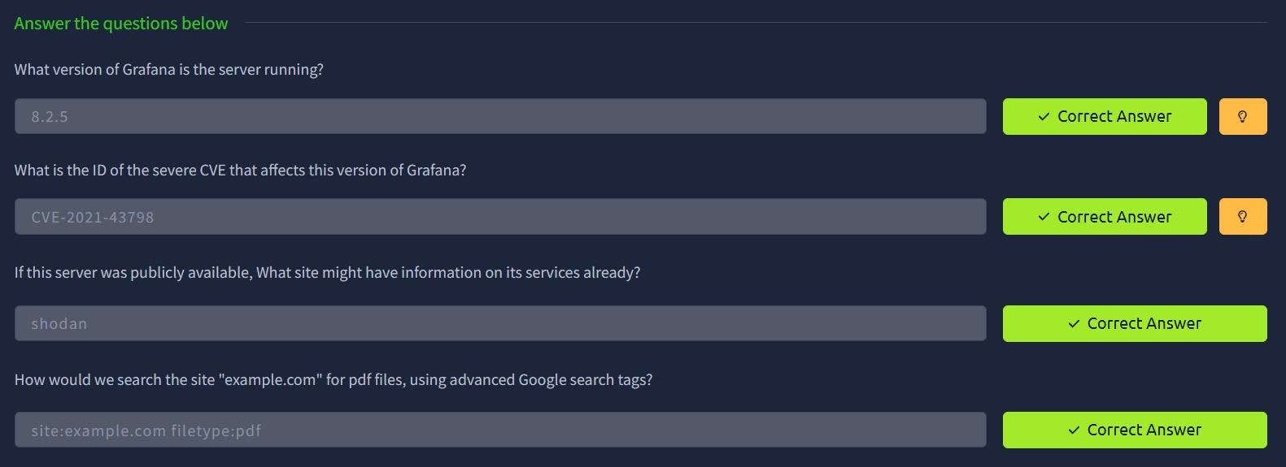

TASK 6 - Rulesets

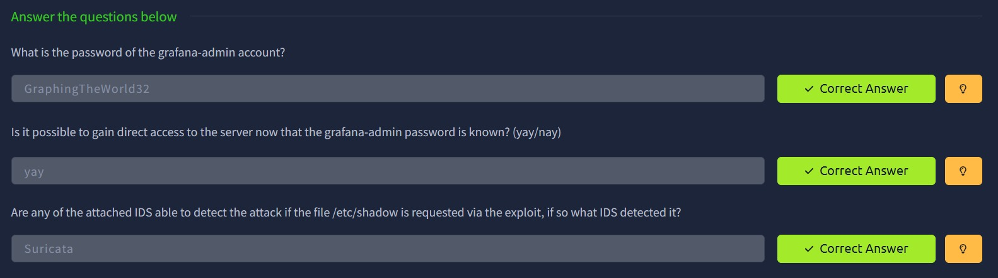

TASK 7 - Host Based IDS (HIDS)



TASK 8 - Privilege Escalation Recon

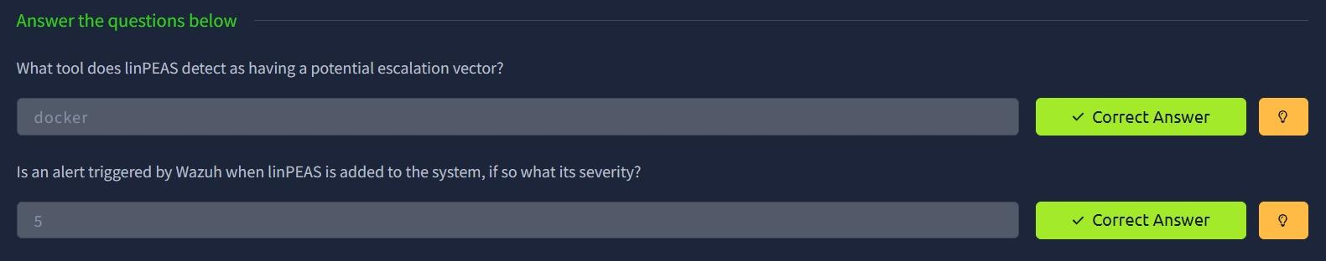

TASK 9 - Performing Privilege Escalation



RESULT

Understood how IDS detects attacks and how evasion techniques can reduce detection during different attack stages.

